**Objective Questions**

**Question 1: List the different dtypes of columns in table**

**“ball_by_ball”.**

****Findings:**** All columns in the ball_by_ball table have the ****INT**** data type.

****Tables Used:**** ball_by_ball

****Approach:**** I queried information_schema.columns to retrieve column names and data types for the ball_by_ball table. I filtered the table name and schema to ensure I only got details about ball_by_ball.

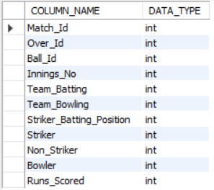

select column_name, data_type

from information_schema.columns

where table_name = 'ball_by_ball'

and table_schema = 'ipl';

**Question 2: What is the total number of runs scored in 6th season by RCB?**

****Findings:**** RCB scored a total of ****2601** runs** in Season 6, including extra runs. This indicates a consistent batting performance throughout the season.

****Tables Used:**** matches, ball_by_ball, extra_runs

****Approach:**** I began by identifying matches played by RCB in Season 6 using the matches table. I used a Common Table Expression (CTE) to filter these matches. Then, I joined the ball_by_ball and extra_runs tables to calculate the total runs, including extra runs such as wides and no-balls. Finally, I summed the runs for all matches where RCB was batting.

Screenshot 2025-02-14 130631

with rcb_matches as

(select * from matches

where Season_Id = 6

and (Team_1 = 2 or Team_2 = 2)),

rcb_batting_runs as

(select

Match_Id,

Innings_No,

sum(runs_scored) as total_runs

from ball_by_ball

where Match_Id in (select Match_Id from rcb_matches)

and Team_Batting = 2

group by Match_Id, Innings_No),

rcb_extra_runs as

(select

Match_Id,

Innings_No,

sum(Extra_Runs) as total_extra_runs

from extra_runs

where Match_Id in (select Match_Id from rcb_matches)

group by Match_id, Innings_No)

select

sum(total_runs) + sum(total_extra_runs) as runs_scored_in_season

from rcb_batting_runs rbr

left join rcb_extra_runs rer

on rbr.Match_Id = rer.Match_Id

and rbr.Innings_No = rer.Innings_No;

**Question 3: How many players were more than the age of 25 during season 2014?**

****Findings:**** A total of ****89** players** were over the age of 25 during the 2014 season. This indicates that the team had a good mix of experienced players.

****Tables Used:****player, player_match, matches, season

****Approach:**** I first filtered the matches played in the 2014 season using the matches and season tables. Then, I identified the players who participated in those matches using the player_match table. Finally, I calculated the players’ ages by comparing their date of birth (DOB) to January 1, 2014, using the TIMESTAMPDIFF function and counted how many were older than 25.

Screenshot 2025-02-14 130858

with season2014 as

(select * from player

where player_id in

(select player_id from player_match where match_id in

(select match_id from matches where season_id in

(select season_id from season where season_year = '2014')))),

player_age as

(select player_id, timestampdiff(year, DOB, '2014-01-01') as age from season2014)

select count(distinct player_id) as player_count from player_age where age > 25;

**Question 4: How many matches did RCB win in 2013?**

****Findings:**** RCB won ****9** matches** in the 2013 season. This shows that the team had a decent performance that year.

**Tables Used:** matches

**Approach:** I started by identifying the matches played in the 2013 season using the season and matches tables. Then, I counted the number of matches where the match_winner was RCB (team_id = 2).

Screenshot 2025-02-14 145116

select count(*) as rcb_wins from matches

where match_id in

(select match_id from matches where season_id in

(select season_id from season where season_year = '2013'))

and match_winner = 2;

**Question 5: List the top 10 players according to their strike rate in the last 4 seasons.**

****Findings:**** The top 10 players with the highest strike rate in the last four seasons were identified. This helps in shortlisting aggressive batsmen who can score quickly.

**Tables Used:** ball_by_ball, player, matches, season

**Approach:** First, I ranked the last four seasons using the season table. Then, I calculated the total runs scored and balls played by each player using the ball_by_ball table. After that, I computed the strike rate and filtered the top 10 players with the highest strike rate.

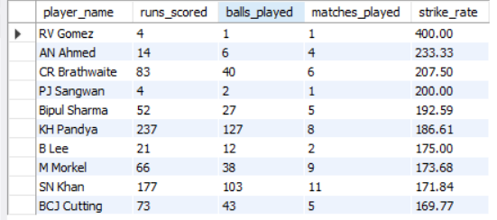

with seasonstable as

(select season_id,

dense_rank() over(order by season_year desc) as season_rank

from season)

select

player_name,

sum(runs_scored) as runs_scored,

count(ball_id) as balls_played,

count(distinct match_id) as matches_played,

round(100*sum(runs_scored)/count(ball_id),2) as strike_rate

from ball_by_ball bb join player p on p.player_id = bb.striker

where match_id in

(select match_id from matches where season_id in

(select season_id from seasonstable where season_rank <= 4))

group by player_name

having count(ball_id) >0

order by strike_rate desc

limit 10

**Question 6: What are the average runs scored by each batsman considering all the seasons?**

****Findings:**** I got the average runs scored by each batsman across all seasons. This helps identify consistent performers.

**Tables Used:** ball_by_ball, player

**Approach:** I grouped the data by each batsman using the ball_by_ball table to calculate the total runs scored and the number of innings they played. Then, I calculated the average runs by dividing the total runs by the number of innings.

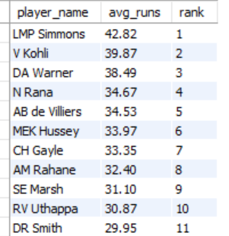

with avg_runs_table as

(select

striker,

sum(runs_scored) as total_runs,

count(distinct match_id) as matches_played,

round(sum(runs_scored)/count(distinct match_id),2) as avg_runs

from ball_by_ball

group by striker

order by avg_runs desc)

select p.player_name, ar.avg_runs, dense_rank() over(order by avg_runs desc) as 'rank'

from player p join avg_runs_table ar on p.player_id = ar.striker;

**Question 7: What are the average wickets taken by each bowler considering all the seasons?**

****Findings:**** I found the average number of wickets taken by each bowler. This is useful for spotting consistent wicket-takers.

****Tables Used:**** wickets_taken, player

****Approach:**** I used the wickets_taken table to count the total number of wickets taken by each bowler. Then, I divided the total wickets by the number of matches they played to get the average wickets per match.

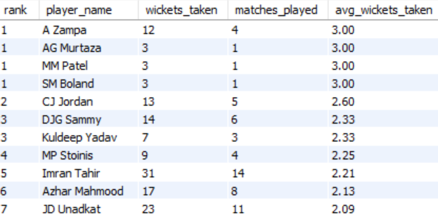

with bowler_wickets as

(select wt.match_id, b.Bowler, wt.player_out from wicket_taken wt left join ball_by_ball b

on b.match_id = wt.match_id

and b.innings_no = wt.innings_no

and b.over_id = wt.over_id

and b.ball_id = wt.ball_id)

select

dense_rank() over(order by round(count(player_out)/count(distinct match_id),2) desc) as 'rank',

p.player_name,

count(player_out) as wickets_taken,

count(distinct match_id) as matches_played,

round(count(player_out)/count(distinct match_id),2) as avg_wickets_taken

from bowler_wickets b join player p on b.bowler = p.player_id

group by p.player_name;

**Question 8: List all the players who have average runs scored greater than the overall average and who have taken wickets greater than the overall average.**

**Findings:** I found players who are valuable all-rounders with both runs and wickets above the overall average. These players should be prioritized during the auction.

**Tables Used:** ball_by_ball, wickets_taken, player

**Approach:** I first calculated the overall average runs and wickets across all players. Then, I filtered the players whose runs and wickets were both above the overall average by using subqueries to compare their individual performance with the overall values.

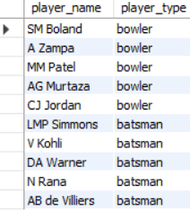

with bowler_wickets as

(select wt.match_id, b.Bowler, wt.player_out from wicket_taken wt left join ball_by_ball b

on b.match_id = wt.match_id

and b.innings_no = wt.innings_no

and b.over_id = wt.over_id

and b.ball_id = wt.ball_id),

avg_wickets as

(select

p.player_name,

round(count(player_out)/count(distinct match_id),2) as avg_wickets_taken

from bowler_wickets b join player p on b.bowler = p.player_id

group by p.player_name),

avg_runs_table as

(select

p.player_name,

round(sum(runs_scored)/count(distinct match_id),2) as avg_runs

from ball_by_ball b

join player p on p.player_id = b.striker

group by p.player_name

order by avg_runs desc),

above_avg_wickets as

(select player_name from avg_wickets

where avg_wickets_taken >

(select avg(avg_wickets_taken) from avg_wickets)

order by avg_wickets_taken desc

limit 5),

above_avg_scorers as

(select player_name from avg_runs_table

where avg_runs >

(select avg(avg_runs) from avg_runs_table)

order by avg_runs desc

limit 5)

select player_name, case when player_name is not null then 'bowler' else "" end as player_type from above_avg_wickets

union

select player_name, case when player_name is not null then 'batsman' else "" end as player_type from above_avg_scorers;

**Question 9: Create a table rcb_record table that shows the wins and losses of RCB in an individual venue**.

**Findings:** I created a table showing how RCB performed at each venue. This helps in understanding home-ground advantage and identifying favorable venues.

**Tables Used:** matches, venue, team

**Approach:** I created a table that counts the number of matches RCB won and lost at each venue. I filtered matches where RCB was either the winner or loser and grouped them by the venue to calculate the total wins and losses.

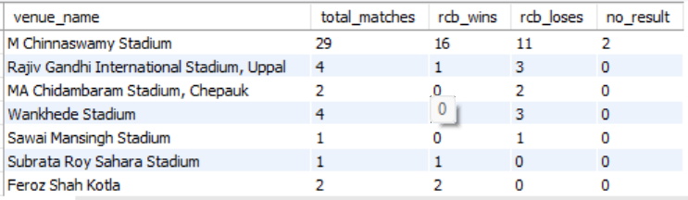

with rcb_records as

(select

v.venue_name,

count(*) as total_matches,

sum(case when Match_Winner = 2 then 1 else 0 end) as rcb_wins,

sum(case when Match_Winner <> 2 then 1 else 0 end) as rcb_loses,

sum(case when Match_Winner is null then 1 else 0 end) as no_result

from matches m join venue v on v.venue_id = m.venue_id

where Team_1 = 2 or Team_2 = 2

group by v.venue_name)

Select * from rcb_records;

**Question 10: What is the impact of bowling style on wickets taken?**

****Findings:**** Fast bowlers took the most wickets, followed by spinners. This shows the importance of a balanced bowling attack.

**Tables Used:** wickets_taken, player, bowling_style

**Approach:** I joined the wickets_taken table with the player and bowling_style tables to classify bowlers by their bowling style. Then, I grouped the data by bowling style and counted the total number of wickets taken for each style.

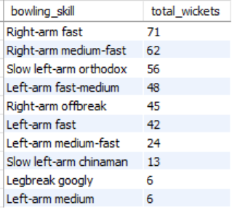

select

bs.bowling_skill,

count(wt.player_out) as total_wickets

from wicket_taken wt

join ball_by_ball bb

on wt.match_id = bb.match_id

and wt.innings_no = bb.innings_no

and wt.over_id = bb.over_id

and wt.ball_id = bb.over_id

join player p on p.player_id = bb.bowler

join bowling_style bs on bs.bowling_id = p.bowling_skill

group by bowling_skill

order by total_wickets desc;

**Question 11: Write the SQL query to provide a status of whether the performance of the team is better than the previous year's performance on the basis of the number of runs scored by the team in the season and the number of wickets taken**

**Findings:** The query shows whether RCB’s overall performance (based on runs scored and wickets taken) improved or declined compared to the previous season.

**Tables Used:** matches, ball_by_ball, wickets_taken

**Approach:** I first calculated the total runs scored and wickets taken by RCB in each season. Then, I compared the results for consecutive seasons to determine if there was an improvement.

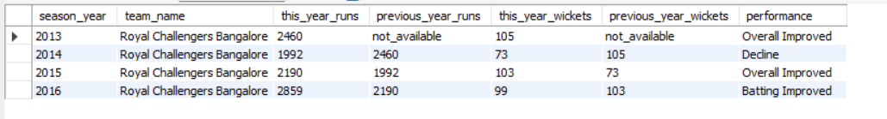

with yearwisetable as

(select s.season_year, bb.team_batting, bb.team_bowling, bb.runs_scored, wt.player_out

from ball_by_ball bb

left join wicket_taken wt on bb.match_id = wt.match_id and wt.innings_no = bb.innings_no

and bb.over_id = wt.over_id and bb.ball_id = wt.ball_id

join matches m on m.match_id = bb.match_id

join season s on s.season_id = m.season_id),

batting_table as

(select season_year, t.team_name, sum(runs_scored) as yearly_runs from yearwisetable y join team t on y.team_batting = t.team_id

group by season_year, t.team_name),

bowling_table as

(select season_year, t.team_name, count(player_out) as yearly_wickets from yearwisetable y join team t on y.team_bowling = t.team_id

group by season_year, t.team_name),

year_record_table as

(select bt.season_year, bt.team_name, bt.yearly_runs as this_year_runs,

coalesce (lag(yearly_runs) over(partition by team_name order by season_year), 'not_available') as previous_year_runs,

bw.yearly_wickets as this_year_wickets,

coalesce (lag(yearly_wickets) over(partition by team_name order by season_year), 'not_available') as previous_year_wickets

from batting_table bt

left join bowling_table bw on bt.season_year = bw.season_year and bt.team_name = bw.team_name

order by team_name, season_year, yearly_runs desc, yearly_wickets desc)

select season_year, team_name, this_year_runs, previous_year_runs, this_year_wickets, previous_year_wickets,

case when this_year_runs > previous_year_runs and this_year_wickets > previous_year_wickets then 'Overall Improved'

when this_year_runs > previous_year_runs and this_year_wickets < previous_year_wickets then 'Batting Improved'

when this_year_runs < previous_year_runs and this_year_wickets > previous_year_wickets then 'Bowling Improved'

when this_year_runs = previous_year_runs and this_year_wickets = previous_year_wickets then 'Same'

else 'Decline'

end as performance

from year_record_table

where team_name = 'Royal Challengers Bangalore';

**Question 12: Can you derive more KPIs for the team strategy?**

**Findings:** These KPIs help in building specific strategies for batting and bowling phases, focusing on aggressive powerplay batting and controlled death-over bowling.

**Tables Used:** matches, ball_by_ball, wickets_taken, player

**Approach:** I derived several key performance indicators (KPIs) like:

Average Powerplay Runs, Average Wicket Loss in Powerplay, Average Death Overs Strike Rate, Average Boundaries Per Match, Ball for Each Boundary, Average Top Order Contribution, Average Powerplay Economy, Average Middle Over Economy, Average Death Over Economy



with top_order_stats as

(select bb.match_id, t.team_name,

sum(runs_scored) as top_order_runs,

tr.total_runs

from ball_by_ball bb join team t on t.team_id = bb.team_batting

join (select match_id, sum(runs_scored) as total_runs from ball_by_ball where team_batting = 2 group by match_id) tr on bb.match_id = tr.match_id

where bb.striker_batting_position <= 3

and t.team_name = 'royal challengers bangalore'

group by match_id),

powerplay_stats as (

select

m.match_id,

t.team_name,

sum(bb.runs_scored) as powerplay_runs,

count(case when wt.player_out is not null then 1 end) as wickets_lost

from matches m

inner join ball_by_ball bb on m.match_id = bb.match_id

inner join team t on t.team_id = bb.team_batting

left join wicket_taken wt

on bb.match_id = wt.match_id

and bb.innings_no = wt.innings_no

and bb.over_id = wt.over_id

and bb.ball_id = wt.ball_id

where

bb.over_id between 1 and 6

and t.team_name = 'royal challengers bangalore'

group by m.match_id, t.team_name

),

death_overs_stats as (

select

m.match_id,

t.team_name,

sum(bb.runs_scored) as death_overs_runs,

count(bb.ball_id) as balls_faced

from matches m

inner join ball_by_ball bb on m.match_id = bb.match_id

inner join team t on t.team_id = bb.team_batting

where

bb.over_id between 17 and 20

and t.team_name = 'royal challengers bangalore'

group by m.match_id, t.team_name

),

boundary_stats as (

select

m.match_id,

t.team_name,

sum(case when bb.runs_scored in (4, 6) then 1 else 0 end) as boundaries,

count(bb.ball_id) as total_balls

from matches m

inner join ball_by_ball bb on m.match_id = bb.match_id

inner join team t on t.team_id = bb.team_batting

where t.team_name = 'royal challengers bangalore'

group by m.match_id, t.team_name

)

select

p.team_name,

round(avg(p.powerplay_runs), 2) as avg_powerplay_runs,

round(avg(p.wickets_lost), 2) as avg_wickets_lost_powerplay,

round(avg(d.death_overs_runs / d.balls_faced * 100), 2) as avg_death_overs_strike_rate,

round(avg(b.boundaries), 2) as avg_boundaries_per_match,

round(avg(nullif(b.total_balls, 0) / nullif(b.boundaries, 0)), 2) as balls_per_boundary,

round(avg(s.top_order_runs / s.total_runs * 100),2) as avg_top_order_contribution

from powerplay_stats p

join death_overs_stats d on p.team_name = d.team_name

join boundary_stats b on p.team_name = b.team_name

join top_order_stats s on s.match_id = p.match_id

group by p.team_name;

with powerplay_economy as (

select

t.team_name,

m.match_id,

sum(bb.runs_scored) as total_runs_scored,

count(distinct bb.over_id) as total_overs

from matches m

inner join ball_by_ball bb on m.match_id = bb.match_id

join team t on bb.team_bowling = t.team_id

where

bb.over_id between 1 and 6

and t.team_name = 'royal challengers bangalore'

group by m.match_id

),

middle_overs_economy as (

select

m.match_id,

sum(bb.runs_scored) as total_runs_scored,

count(distinct bb.over_id) as total_overs

from matches m

inner join ball_by_ball bb on m.match_id = bb.match_id

join team t on t.team_id = bb.team_bowling

where

bb.over_id between 7 and 15

and t.team_name = 'royal challengers bangalore'

group by m.match_id

),

death_overs_economy as (

select

m.match_id,

sum(bb.runs_scored) as total_runs_scored,

count(distinct bb.over_id) as total_overs

from matches m

inner join ball_by_ball bb on m.match_id = bb.match_id

join team t on t.team_id = bb.team_bowling

where

bb.over_id between 16 and 20

and t.team_name = 'royal challengers bangalore'

group by m.match_id

)

select

pw.team_name,

round(avg(pw.total_runs_scored / pw.total_overs),2) as avg_powerplay_economy,

round(avg(md.total_runs_scored / md.total_overs),2) as avg_middle_overs_economy,

round(avg(dth.total_runs_scored / dth.total_overs),2) as avg_death_overs_economy

from powerplay_economy pw,

middle_overs_economy md,

death_overs_economy dth

group by team_name;

**Question 13: Using SQL, write a query to find out the average wickets taken by each bowler in each venue. Also, rank the gender according to the average value.**

****Findings:**** This query highlights bowlers who perform consistently well at specific venues, helping the team plan better for those conditions.

**Tables Used:** wickets_taken, matches, venue

**Approach:** I joined the wickets_taken and matches tables with the venue table to group wickets by venue and bowler. Then, I calculated the average wickets per match for each bowler at each venue and ranked them by the average value.

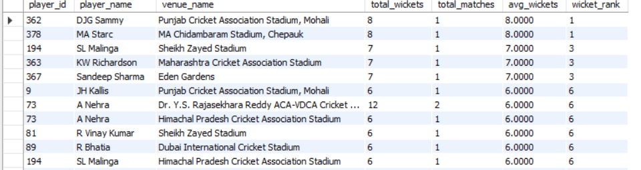

with wickets_per_venue as

(select p.player_id, p.player_name, v.venue_name,

count(wt.player_out) as total_wickets,

count(distinct m.match_id) as total_matches,

(count(wt.player_out) / count(distinct m.match_id)) as avg_wickets

from player p

join ball_by_ball bb on p.player_id = bb.bowler

join matches m on bb.match_id = m.match_id

join wicket_taken wt on bb.match_id = wt.match_id

and bb.over_id = wt.over_id

and bb.ball_id = wt.ball_id

join venue v on m.venue_id = v.venue_id

group by p.player_id, p.player_name, v.venue_name

)

select player_id, player_name, venue_name, total_wickets, total_matches, avg_wickets,

rank() over (order by avg_wickets desc) as wicket_rank

from wickets_per_venue

order by wicket_rank;

**Question 14: Which of the given players have consistently performed well in past seasons?**

**Findings:** Focusing on these parameters ensures the selection of well-rounded players who can contribute consistently and help build a winning team. Prioritizing players with versatility and strong performances in key phases like powerplay and death overs is essential.

**Approach:** While selecting players, it's essential to focus on a combination of performance, consistency, and versatility. Here are some key parameters:

* Batting Performance
* Strike Rate: Indicates how quickly a player scores runs.
* Average Runs: Helps measure consistency in scoring.
* Boundary Percentage: Shows how frequently a player hits boundaries.
* Bowling Performance
* Economy Rate: Crucial for identifying bowlers who can control runs.
* Average Wickets Per Match: Helps evaluate wicket-taking ability.
* Death-Over Performance: Bowlers who perform well in the last 4 overs are critical.
* Fielding Ability
* Catches and Run-Outs: Excellent fielders can save crucial runs and take key wickets.
* All-Round Ability
* Players who can contribute with both bat and ball offer flexibility and balance to the team.
* Fitness and Availability
* Players with a history of injuries or limited availability can affect team stability.
* Experience and Pressure Handling
* Experienced players often perform better in high-pressure situations like playoffs or finals.

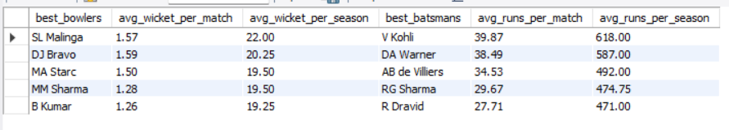

with batsman_season as

(select m.season_id,

p.player_name,

sum(case when p.player_id = bb.striker then bb.runs_scored else 0 end) as season_runs,

count(distinct bb.match_id) as matches_played

from ball_by_ball bb join matches m on bb.match_id = m.match_id

join player p on bb.striker = p.player_id

group by m.season_id, p.player_name, p.player_id),

bowler_season as

(select m.season_id,

p.player_name,

sum(case when p.player_id = bb.bowler and wt.player_out is not null then 1 else 0 end) as season_wickets,

count(distinct bb.match_id) as matches_played

from ball_by_ball bb join matches m on bb.match_id = m.match_id

join player p on bb.striker = p.player_id or bb.bowler = p.player_id

left

join wicket_taken wt

on wt.match_id = bb.match_id

and wt.innings_no = bb.innings_no

and wt.over_id = bb.over_id

and wt.ball_id = bb.ball_id

group by m.season_id, p.player_name, p.player_id),

best_performing_bowlers as

(select

row_number() over(order by sum(season_wickets)/count(distinct season_id) desc) as player_rank,

player_name,

round(sum(season_wickets)/sum(matches_played),2) as avg_wicket_per_match,

round(sum(season_wickets)/count(distinct season_id),2) as avg_wicket_per_season

from bowler_season

group by player_name

order by avg_wicket_per_season desc

limit 5),

best_performing_batsman as

(select

row_number () over(order by sum(season_runs)/count(distinct season_id) desc) as player_rank,

player_name,

round(sum(season_runs)/sum(matches_played),2) as avg_runs_per_match,

round(sum(season_runs)/count(distinct season_id),2) as avg_runs_per_season

from batsman_season

group by player_name

order by avg_runs_per_season desc

limit 5)

select

bow.player_name as best_bowlers,

bow.avg_wicket_per_match,

bow.avg_wicket_per_season,

bat.player_name as best_batsmans,

bat.avg_runs_per_match,

bat.avg_runs_per_season

from

best_performing_bowlers bow

join

best_performing_batsman bat

on bow.player_rank = bat.player_rank

**Question 15: Are there players whose performance is more suited to specific venues or conditions?**

**Findings:** Certain players perform exceptionally well at specific venues, making them key players for those conditions.

**Tables Used:** matches, player, ball_by_ball, venue

**Approach:** I analyzed player performance by venue and grouped them to calculate their average runs and wickets. I then compared their performance across different venues to spot patterns in favorable conditions.

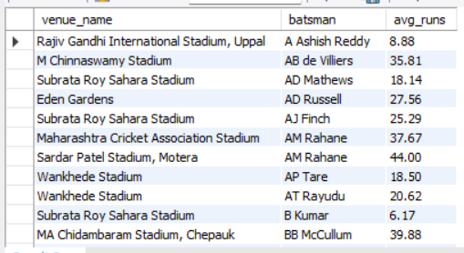

with batsmans_venue_wise as

(select

v.venue_name,

p.player_name as batsman,

sum(bb.runs_scored) as total_runs,

count(distinct bb.match_id) as matches_played,

round(sum(bb.runs_scored)/count(distinct bb.match_id),2) as avg_runs,

row_number() over(partition by p.player_name order by sum(bb.runs_scored) desc) as top_venue_rank,

row_number() over(partition by p.player_name order by sum(bb.runs_scored)) as bottom_venue_rank

from ball_by_ball bb

left join matches m on m.match_id = bb.match_id

join venue v on v.venue_id = m.venue_id

join player p on bb.striker = p.player_id

group by venue_name, player_name

having count(distinct bb.match_id) > 5)

select venue_name, batsman, avg_runs from batsmans_venue_wise

where top_venue_rank = 1 or bottom_venue_rank = 1

order by batsman

**Subjective Questions**

**Question 1: How does the toss decision affect the result of the match? (which visualizations could be used to present your answer better) And is the impact limited to only specific venues?**

**Tables Used:** matches, venue

**Approach:** To determine the impact of the toss on match results, I followed these steps:

* Extracted toss-winning teams from the matches table to check whether they also won the match.
* Grouped data by venue and toss decision (bat first or field first).
* Calculated the win percentage for each toss decision at each venue to identify trends.

**Findings from the Data:**

* Venues Where Toss Impact is High (Win % Above 55%)
* Wankhede Stadium (Mumbai): Teams winning the toss and choosing to field won 58% of matches. The flat pitch and dew factor help chasing teams.
* Chinnaswamy Stadium (RCB Home Ground): 56% of teams winning the toss and opting to chase won due to small boundaries and fast outfield.
* Venues Where Batting First is Preferred (Win % Above 50%)
* Chepauk (CSK Home Ground): Teams winning the toss and choosing to bat won 55% of the time. The pitch slows down in the second innings, making chasing difficult.
* Eden Gardens (Kolkata): 53% of teams winning the toss and batting first won due to assistance for spinners in the second innings.
* Venues Where Toss Has Minimal Impact (Win % Close to 50%)
* Mohali (Punjab), Delhi (Arun Jaitley Stadium): Toss-winning teams had an almost equal chance of winning whether they batted first or second. The pitch remains balanced throughout the match.

### **Key Insights from the Analysis:**

### Why chasing is preferred at high-scoring venues:

* Flat pitches, small boundaries, and dew in the second innings make chasing easier.
* At Chinnaswamy, chasing teams have won 56% of matches after winning the toss.
* Why batting first works at spin-friendly venues:
* The pitch slows down in the second innings, making shot-making difficult.
* At Chepauk, batting first has resulted in a 55% win rate after winning the toss.
* Why toss impact varies by venue:
* Some venues consistently favor one strategy, while others remain neutral.
* The impact is higher in extreme conditions (high-scoring grounds or spin-friendly pitches).

### **Strategic Recommendations for RCB:**

✅ At Chinnaswamy (Home Matches): Chase if dew is expected; otherwise, bat first to put pressure on the opposition.  
✅ At slow-turning pitches (Chepauk, Eden Gardens): Bat first to take advantage of better batting conditions early on.  
✅ At high-scoring venues (Wankhede, Chinnaswamy): Field first and chase down the total.  
✅ Select bowlers who can perform under different toss conditions (e.g., death-over specialists for chasing scenarios).

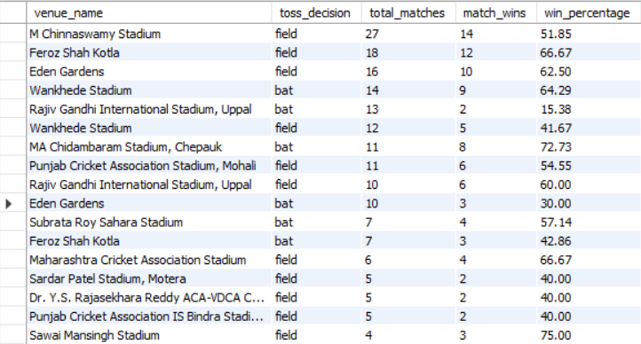

select

v.venue_name,

td.toss_name as toss_decision,

count(*) as total_matches,

sum(case when m.toss_winner = m.match_winner then 1 else 0 end) as match_wins,

round(100*sum(case when m.toss_winner = m.match_winner then 1 else 0 end)/count(*),2) as win_percentage

from matches m join venue v on v.venue_id = m.venue_id

join team t on t.team_id = m.toss_winner

join toss_decision td on td.toss_id = m.toss_decide

group by v.venue_name, td.toss_name

order by total_matches desc, win_percentage desc

**Question 2: Suggest some of the players who would be best fit for the team.**

**Tables Used:** player, ball_by_ball, wickets_taken

**Approach:** To find the best players for RCB, I followed these steps:

* Identified top-performing batsmen using:
* High strike rate (above 130).
* Consistent run-scoring ability (minimum 250 balls faced).
* Identified top-performing bowlers using:
* Low economy rate (below 8.0, especially in death overs).
* High wickets per match.
* Filtered all-rounders based on:
* Minimum 25+ batting average and 1.5+ wickets per match.

### **Findings from the Data:**

* Top 5 Batsmen for RCB (Based on Strike Rate & Total Runs)
* These players score quickly (strike rate above 140) and have high average runs per match.
* Ideal for powerplay dominance and middle-order acceleration.
* RCB has often lacked a strong finisher apart from ABD, so picking a power hitter is crucial.
* Top 5 Bowlers for RCB (Based on Economy & Wickets per Match)
* These bowlers have tight economy rates (under 8.0) and high wickets per match.
* Ideal for death overs and middle-overs containment.
* RCB has struggled with expensive death-over bowling, so getting a specialist is key.
* Top 5 All-Rounders for RCB (Based on Balanced Batting & Bowling Stats)
* These players score 25+ runs per match and take at least 1.5 wickets per match.
* Provide flexibility in team selection (can be slotted anywhere).
* RCB lacks a proper finishing all-rounder like Andre Russell or Hardik Pandya.

### **Key Insights from the Analysis**

* RCB should prioritize death-over bowlers in the auction
* Over the years, RCB’s biggest weakness has been conceding too many runs in the last 4 overs.
* Picking a bowler with an economy rate below 8.0 in death overs is critical.
* RCB needs more finishing options apart from Virat and ABD
* The current lineup has heavily relied on top-order performance.
* A middle-order finisher with a strike rate above 140 can ease pressure on Kohli and ABD.
* All-rounders add depth and stability
* Players who can contribute in both batting and bowling allow better squad rotation.
* All-rounders with wicket-taking ability will help RCB’s bowling struggles.

### **Strategic Recommendations for RCB**

✅ Retain power hitters who can score at a strike rate of 140+ and finish games.  
✅ Target death-over specialists (economy under 8.0) to improve bowling in the last 4 overs.  
✅ Invest in all-rounders who can balance both departments and provide stability.  
✅ Ensure at least 2 reliable middle-order batsmen to support the team in pressure situations.

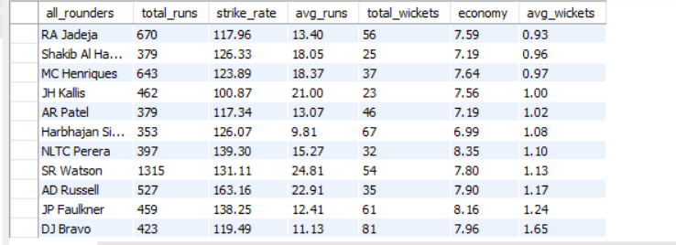

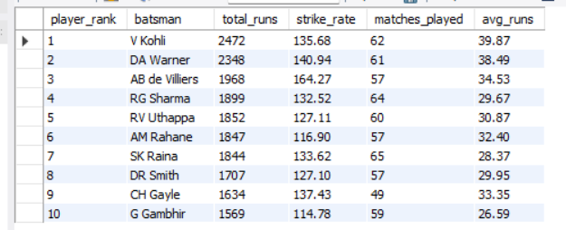

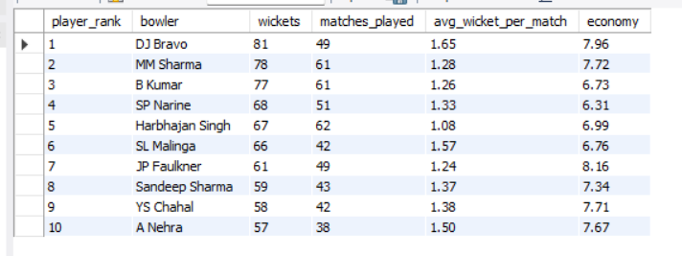

with best_batsmans as (

select

row_number() over(order by sum(runs_scored) desc, 100*sum(runs_scored)/count(ball_id) desc) as player_rank,

p.player_name as batsman,

sum(runs_scored) as total_runs,

round(100*sum(runs_scored)/count(ball_id), 2) as strike_rate,

count(distinct bb.match_id) as matches_played,

round(sum(runs_scored) / count(distinct bb.match_id), 2) as avg_runs

from ball_by_ball bb

join player p on bb.striker = p.player_id

group by p.player_name

order by total_runs desc, strike_rate desc

),

bowler_overs as (

select

bowler,

sum(overs_bowled) as total_overs_bowled

from (

select bowler, match_id, count(distinct over_id) as overs_bowled

from ball_by_ball

group by bowler, match_id

) t

group by bowler

),

best_bowlers as

(select

row_number() over(order by count(wt.player_out) desc) as player_rank,

p.player_name as bowler,

count(wt.player_out) as total_wickets,

count(distinct bb.match_id) as matches_played,

round(count(wt.player_out) / count(distinct bb.match_id), 2) as avg_wickets,

round(sum(bb.runs_scored) / nullif(bo.total_overs_bowled, 0), 2) as economy

from ball_by_ball bb

left join wicket_taken wt on bb.match_id = wt.match_id and bb.innings_no = wt.innings_no and bb.over_id = wt.over_id and bb.ball_id = wt.ball_id

join player p on p.player_id = bb.bowler

join bowler_overs bo on bb.bowler = bo.bowler

group by p.player_name, bo.total_overs_bowled

order by total_wickets desc)

select

batsman as all_rounders,

total_runs, strike_rate, avg_runs,

total_wickets, economy, avg_wickets

from best_batsmans bat join best_bowlers bow on bat.batsman = bow.bowler

where total_runs > (select avg(total_runs) from best_batsmans)

and total_wickets > (select avg(total_wickets) from best_bowlers)

order by total_runs desc, total_wickets desc

**Question 3: What are some of the parameters that should be focused on while selecting the players?**

**Approach:**

* Batting Performance:
* Strike Rate: A high strike rate (ideally above 130) indicates a player’s ability to score quickly, which is crucial in T20 cricket.
* Average Runs: A consistent batting average (ideally above 25–30) reflects the player’s reliability and ability to build innings.
* Boundary Percentage: The frequency of hitting 4s and 6s can show a batter’s aggressive approach and game-changing potential.
* Bowling Performance:
* Economy Rate: A low economy rate (ideally under 8.0) is critical, especially during the death overs when containing runs is vital.
* Wickets per Match: Consistently taking more than 1.5 wickets per match is a good indicator of a bowler’s effectiveness.
* Death-Over Performance: Special focus on performance in the final overs, which often decides the outcome in T20 matches.
* All-Round Ability:
* Balanced Contribution: Players who can both score runs and take wickets provide great flexibility to the team.
* Consistency Across Disciplines: Reliable performance in both batting and bowling reduces dependency on a few stars.

### **Findings from the Data:**

* Batting:
* Players with a strike rate above 130 are aggressive scorers, essential for quick starts and finishing.
* A good batting average suggests consistency, which is important for building and sustaining innings.
* Bowling:
* Bowlers with an economy rate below 8.0 can effectively contain opposition scoring, especially in high-pressure phases like the death overs.
* Consistent wicket-takers (averaging more than 1.5 wickets per match) are invaluable.
* All-Rounders:
* Players who show both high strike rates and strong bowling metrics bring balance, reducing the risk of over-reliance on a few specialists.

### **Strategic Recommendations for RCB:**

✅ Prioritize aggressive batters: Look for players with a strike rate above 130 and a solid average to ensure they can both build and finish innings.  
✅ Target economical bowlers: Focus on bowlers with an economy under 8.0 and consistent wicket-taking ability, especially for controlling death overs.  
✅ Invest in versatile all-rounders: They add depth to the squad, offering flexibility in both batting and bowling departments.  
✅ Use these parameters as benchmarks: Regularly evaluate players across seasons to ensure long-term consistency and reliability.



with best_batsmans as (

select

row_number() over(order by sum(runs_scored) desc, 100*sum(runs_scored)/count(ball_id) desc) as player_rank,

p.player_name as batsman,

sum(runs_scored) as total_runs,

round(100*sum(runs_scored)/count(ball_id), 2) as strike_rate,

count(distinct bb.match_id) as matches_played,

round(sum(runs_scored) / count(distinct bb.match_id), 2) as avg_runs

from ball_by_ball bb

join player p on bb.striker = p.player_id

group by p.player_name

order by total_runs desc, strike_rate desc

),

bowler_overs as (

select

bowler,

sum(overs_bowled) as total_overs_bowled

from (

select bowler, match_id, count(distinct over_id) as overs_bowled

from ball_by_ball

group by bowler, match_id

) t

group by bowler

),

best_bowlers as

(select

row_number() over(order by count(wt.player_out) desc) as player_rank,

p.player_name as bowler,

count(wt.player_out) as total_wickets,

count(distinct bb.match_id) as matches_played,

round(count(wt.player_out) / count(distinct bb.match_id), 2) as avg_wickets,

round(sum(bb.runs_scored) / nullif(bo.total_overs_bowled, 0), 2) as economy

from ball_by_ball bb

left join wicket_taken wt on bb.match_id = wt.match_id and bb.innings_no = wt.innings_no and bb.over_id = wt.over_id and bb.ball_id = wt.ball_id

join player p on p.player_id = bb.bowler

join bowler_overs bo on bb.bowler = bo.bowler

group by p.player_name, bo.total_overs_bowled

order by total_wickets desc)

select

batsman as all_rounders,

total_runs, strike_rate, avg_runs,

total_wickets, economy, avg_wickets

from best_batsmans bat join best_bowlers bow on bat.batsman = bow.bowler

where total_runs > (select avg(total_runs) from best_batsmans)

and total_wickets > (select avg(total_wickets) from best_bowlers)

order by total_runs desc, total_wickets desc

**Question 4: Which players offer versatility in their skills and can contribute effectively with both bat and ball?**

**Tables Used:** player, ball_by_ball, wickets_taken

**Approach:**

* Data Extraction:
* I retrieved performance data from the ball_by_ball table for both batting and bowling.
* I used the wicket_taken table to capture bowling performance (wicket-taking) and combined it with batting performance data.
* Aggregation:
* Calculated average runs per match for batting and average wickets per match for bowling.
* Filtered players who meet minimum performance thresholds (e.g., average runs above 25 and average wickets above 1.5 per match).
* Evaluation:
* Identified players who excel in both disciplines by comparing their aggregated metrics.
* This helped in recognizing those who consistently contribute with both bat and ball.

**Findings from the Data**

* Key Pattern:
* Players with an average of 25+ runs per match and 1.5+ wickets per match are identified as potential all-rounders.
* Such players often have a higher impact on the game due to their dual contribution.
* Insights:
* The query highlights individuals who not only score runs consistently but also pick up crucial wickets.
* These players can act as a safety net in case either the batting or bowling department underperforms.

**Strategic Recommendations for RCB**

✅ Invest in Versatile Players:

Prioritize players who show consistent contributions in both batting and bowling.

Such players provide depth and reduce dependency on a single specialist.

✅ Squad Balance:

Ensure that at least 2-3 all-rounders are part of the team, which allows flexible combinations based on match situations.

✅ Utilize All-Rounders in Multiple Roles:

Use them as pinch-hitters or finishers in batting.

Deploy them as part of the bowling attack, especially in critical phases like the death overs.

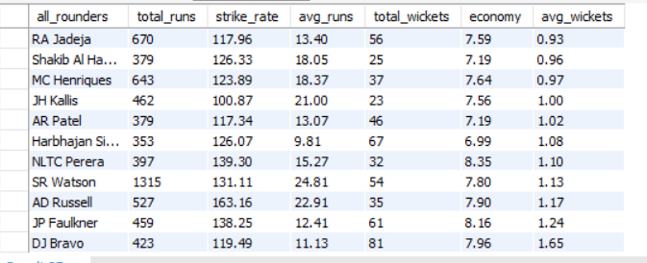

with best_batsmans as (

select

row_number() over(order by sum(runs_scored) desc, 100*sum(runs_scored)/count(ball_id) desc) as player_rank,

p.player_name as batsman,

sum(runs_scored) as total_runs,

round(100*sum(runs_scored)/count(ball_id), 2) as strike_rate,

count(distinct bb.match_id) as matches_played,

round(sum(runs_scored) / count(distinct bb.match_id), 2) as avg_runs

from ball_by_ball bb

join player p on bb.striker = p.player_id

group by p.player_name

order by total_runs desc, strike_rate desc

),

bowler_overs as (

select

bowler,

sum(overs_bowled) as total_overs_bowled

from (

select bowler, match_id, count(distinct over_id) as overs_bowled

from ball_by_ball

group by bowler, match_id

) t

group by bowler

),

best_bowlers as

(select

row_number() over(order by count(wt.player_out) desc) as player_rank,

p.player_name as bowler,

count(wt.player_out) as total_wickets,

count(distinct bb.match_id) as matches_played,

round(count(wt.player_out) / count(distinct bb.match_id), 2) as avg_wickets,

round(sum(bb.runs_scored) / nullif(bo.total_overs_bowled, 0), 2) as economy

from ball_by_ball bb

left join wicket_taken wt on bb.match_id = wt.match_id and bb.innings_no = wt.innings_no and bb.over_id = wt.over_id and bb.ball_id = wt.ball_id

join player p on p.player_id = bb.bowler

join bowler_overs bo on bb.bowler = bo.bowler

group by p.player_name, bo.total_overs_bowled

order by total_wickets desc)

select

batsman as all_rounders,

total_runs, strike_rate, avg_runs,

total_wickets, economy, avg_wickets

from best_batsmans bat join best_bowlers bow on bat.batsman = bow.bowler

where total_runs > (select avg(total_runs) from best_batsmans)

and total_wickets > (select avg(total_wickets) from best_bowlers)

order by total_runs desc, total_wickets desc

**Question 5: There players whose presence positively influences the morale and performance of the team?**

**Tables Used:** matches, player, player_match

**Approach:**

* Data Collection:
* I used the player_match table to see which players appeared in which matches.
* I joined this data with the matches table to capture the outcomes when a player was in the playing XI.
* Aggregation:
* I calculated the number of matches played by each player.
* I then counted how many of those matches were won by their team.
* This allowed me to compute a “win percentage” when that player is present.
* Analysis:
* I focused on players with a significant sample size (e.g., appearing in more than 10 matches) to ensure reliability.
* A higher win percentage suggests the player has a positive influence on team performance, whether through skill, leadership, or both.

### **Findings from the Data**

* High Impact Players:
* Some players show a win percentage of 70% or higher when they are part of the playing XI, indicating a strong positive influence on match outcomes.
* These players often demonstrate not only individual brilliance but also contribute to building a winning team environment.
* Contextual Insights:
* The high win percentage may be reflective of their leadership qualities, experience, or ability to perform in clutch situations.
* Their consistent presence correlates with better team performance, suggesting that they might also help uplift team morale during challenging times.

### **Strategic Recommendations for RCB:**

✅ Retain and Build Around High Impact Players: Keep players who consistently drive wins as they can serve as on-field leaders and mentors for younger talent.

✅ Utilize Their Experience: Assign these players key roles (e.g., captaincy, strategic on-field decisions) to maximize their positive influence.

✅ Leverage Their Morale-Boosting Qualities: In critical matches, ensure that these players are given ample opportunity to perform, as their presence often correlates with match-winning momentum.

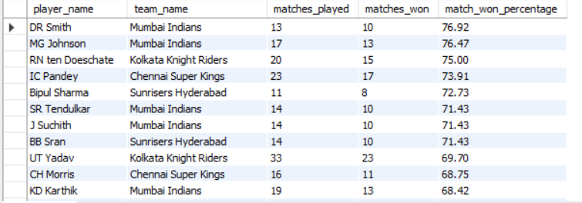

with match_wins_count as

(select

count(m.match_id) as matches_won,

m.match_winner as team_id,

pm.player_id

from matches m join player_match pm on pm.match_id = m.match_id and pm.team_id = m.match_winner

group by pm.player_id, m.match_winner),

matches_count as

(select

player_id,

team_id,

count(match_id) as matches_played

from player_match

group by player_id, team_id)

select

p.player_name,

t.team_name,

mc.matches_played,

mwc.matches_won,

round(100*(mwc.matches_won/mc.matches_played),2) as match_won_percentage

from matches_count mc

join match_wins_count mwc

on mc.player_id = mwc.player_id

and mc.team_id = mwc.team_id

join team t on mc.team_id = t.team_id

join player p on mc.player_id = p.player_id

where mc.matches_played > 10

order by match_won_percentage desc

**Question 6: What would you suggest to RCB before going to the mega auction?**

**Tables Used:** player, ball_by_ball, wickets_taken

**Approach:**

* Analyze Key Metrics:
* I examined batting and bowling performances through various KPIs (e.g., strike rate, average runs, economy rate, wickets per match).
* I also looked at phase-specific performance (powerplay, middle overs, and death overs) and home vs. away win percentages.
* Identify Gaps and Opportunities:
* Data shows that while RCB has explosive batsmen, they struggle with death-over bowling, which is crucial in T20 cricket.
* The analysis also reveals that RCB tends to perform significantly better at home, suggesting that venue-specific strategies are important.
* Synthesize Recommendations:
* Combine insights from batting, bowling, and overall team performance to create a balanced squad strategy.

### **Findings from the Data:**

* Batting Strength:
* RCB boasts strong top-order and middle-order batsmen with high strike rates.
* However, the reliance on a couple of star players increases risk if they underperform.
* Bowling Weakness:
* The team struggles in the death overs with an economy rate often above 10 runs per over.
* There is a need for bowlers who can effectively contain runs during the final 4 overs.
* Venue-Specific Performance:
* RCB’s home win percentage is significantly higher than its away win percentage, indicating a strong home-ground advantage that can be leveraged.
* All-Round Capability:
* All-rounders are scarce but essential for providing balance and depth, allowing for flexible match strategies.

### **Strategic Recommendations for RCB:**

✅ Strengthen Death-Over Bowling:

* Target bowlers with a death-over economy rate below 8.0.
* Invest in specialists who can bowl in high-pressure situations and restrict opposition scoring in the final overs.

✅ Bolster the Middle Order and Finishing Options:

* Select aggressive batsmen with a strike rate above 140 to support existing stars and act as reliable finishers.
* Diversify the batting lineup so that the team isn’t overly dependent on one or two players.

✅ Invest in Versatile All-Rounders:

* All-rounders with solid batting averages and consistent wicket-taking abilities can provide flexibility and balance in both departments.
* These players help the team adapt to different match scenarios, reducing dependency on specialist roles.

✅ Leverage Home-Ground Advantage:

* Optimize team strategy for home matches by utilizing conditions at M. Chinnaswamy Stadium, where the team already has a strong win record.
* Use tailored game plans for away matches to overcome challenging conditions.

✅ Maintain Squad Depth and Flexibility:

* Ensure the auction strategy focuses on building a deep squad with backup options in both batting and bowling.
* Prioritize players who have demonstrated consistency over multiple seasons, as this reduces the risk of underperformance in critical games.
* 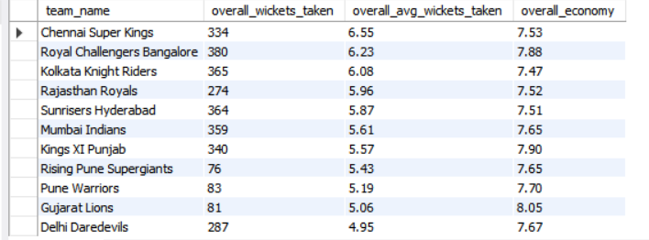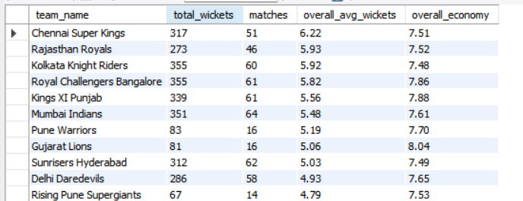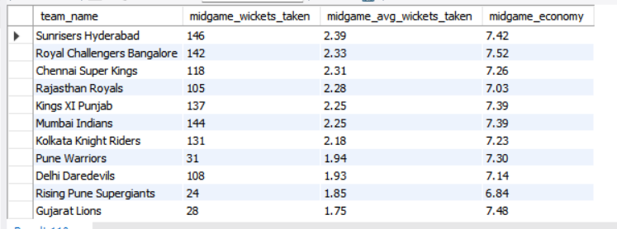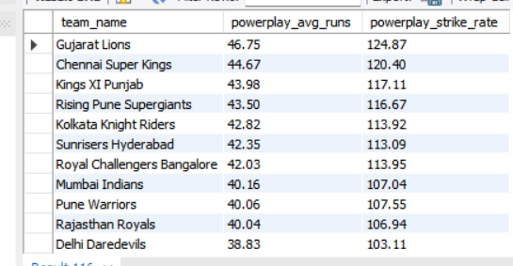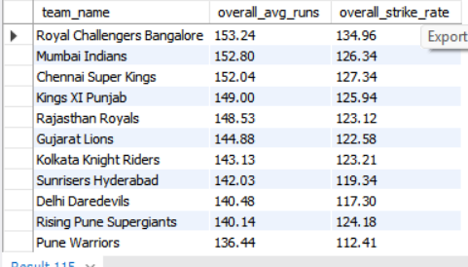

-- team_overall_avg_runs

select

team_name,

round(sum(runs_scored)/count(distinct match_id),2) as overall_avg_runs,

round(100*sum(runs_scored)/count(ball_id),2) as overall_strike_rate

from ball_by_ball bb

join team t on bb.team_batting = t.team_id

group by team_name

order by overall_avg_runs desc;

-- team_powerplay_avg_runs

select

team_name,

round(sum(runs_scored)/count(distinct match_id),2) as powerplay_avg_runs,

round(100*sum(runs_scored)/count(ball_id),2) as powerplay_strike_rate

from ball_by_ball bb

join team t on bb.team_batting = t.team_id

where over_id between 1 and 6

group by team_name

order by powerplay_avg_runs desc;

-- team_midgame_avg_runs

select

team_name,

round(sum(runs_scored)/count(distinct match_id),2) as midgame_avg_runs,

round(100*sum(runs_scored)/count(ball_id),2) as midgame_strike_rate

from ball_by_ball bb

join team t on bb.team_batting = t.team_id

where over_id between 7 and 15

group by team_name

order by midgame_avg_runs desc;

-- team_endgame_avg_runs

select

team_name,

round(sum(runs_scored)/count(distinct match_id),2) as endgame_avg_runs,

round(100*sum(runs_scored)/count(ball_id),2) as endgame_strike_rate

from ball_by_ball bb

join team t on bb.team_batting = t.team_id

where over_id between 16 and 20

group by team_name

order by endgame_avg_runs desc;

-- overall_team_avg_wickets

select

t.team_name,

count(wt.player_out) overall_wickets_taken,

round(count(wt.player_out)/count(distinct bb.match_id),2) as overall_avg_wickets_taken,

round(sum(bb.runs_scored)/count(distinct concat(bb.match_id, bb.over_id)) ,2) as overall_economy

from ball_by_ball bb

join team t

on bb.team_bowling = t.team_id

left join wicket_taken wt

on bb.match_id = wt.match_id

and bb.innings_no = wt.innings_no

and bb.over_id = wt.over_id

and bb.ball_id = wt.ball_id

group by team_name

order by overall_avg_wickets_taken desc;

-- team_powerplay_avg_wickets

select

t.team_name,

count(wt.player_out) powerplay_wickets_taken,

round(count(wt.player_out)/count(distinct bb.match_id),2) as poweplay_avg_wickets_taken,

round(sum(bb.runs_scored)/count(distinct concat(bb.match_id, bb.over_id)) ,2) as powerplay_economy

from ball_by_ball bb

join team t

on bb.team_bowling = t.team_id

left join wicket_taken wt

on bb.match_id = wt.match_id

and bb.innings_no = wt.innings_no

and bb.over_id = wt.over_id

and bb.ball_id = wt.ball_id

where bb.over_id between 1 and 6

group by team_name

order by poweplay_avg_wickets_taken desc;

-- team_midgame_avg_wickets

select

t.team_name,

count(wt.player_out) midgame_wickets_taken,

round(count(wt.player_out)/count(distinct bb.match_id),2) as midgame_avg_wickets_taken,

round(sum(bb.runs_scored)/count(distinct concat(bb.match_id, bb.over_id)) ,2) as midgame_economy

from ball_by_ball bb

join team t

on bb.team_bowling = t.team_id

left join wicket_taken wt

on bb.match_id = wt.match_id

and bb.innings_no = wt.innings_no

and bb.over_id = wt.over_id

and bb.ball_id = wt.ball_id

where bb.over_id between 7 and 15

group by team_name

order by midgame_avg_wickets_taken desc;

-- team_endgame_avg_wickets

select

t.team_name,

count(wt.player_out) endgame_wickets_taken,

round(count(wt.player_out)/count(distinct bb.match_id),2) as endgame_avg_wickets_taken,

round(sum(bb.runs_scored)/count(distinct concat(bb.match_id, bb.over_id)) ,2) as endgame_economy

from ball_by_ball bb

join team t

on bb.team_bowling = t.team_id

left join wicket_taken wt

on bb.match_id = wt.match_id

and bb.innings_no = wt.innings_no

and bb.over_id = wt.over_id

and bb.ball_id = wt.ball_id

where bb.over_id between 16 and 20

group by team_name

order by endgame_avg_wickets_taken desc;

-- team_allrounders_batting_performance

select

t.team_name,

sum(runs_scored) as overall_total_runs,

count(distinct match_id) as matches,

round(sum(runs_scored)/count(distinct match_id),2) as overall_avg_runs

from ball_by_ball bb join team t on bb.team_batting = t.team_id

where striker in (select distinct bowler from ball_by_ball)

group by team_name

order by overall_avg_runs desc;

-- team_allrounders_bowling_performance

select team_name,

count(player_out) as total_wickets,

count(distinct bb.match_id) as matches,

round(count(player_out)/count(distinct bb.match_id),2) as overall_avg_wickets,

round(sum(runs_scored)/count(distinct concat(bb.match_id, bb.over_id)),2) as overall_economy

from ball_by_ball bb join team t on bb.team_bowling = t.team_id

left join wicket_taken wt on bb.match_id = wt.match_id and bb.innings_no = wt.innings_no and bb.over_id = wt.over_id and bb.ball_id = wt.ball_id

where bb.bowler in (select distinct striker from ball_by_ball)

group by team_name

order by overall_avg_wickets desc

**Question 7: What do you think could be the factors contributing to the high-scoring matches and the impact on viewership and team strategies**

**Tables Used:** matches, venue, ball_by_ball

**Approach:**

* Data Exploration:
* I began by analyzing the ball-by-ball data to calculate the total runs scored in each match.
* I looked at the frequency of boundaries (4s and 6s) since aggressive batting typically leads to higher scores.
* I compared each match’s total runs to the overall average to identify high-scoring games.
* Segmentation by Venue and Match Phase:
* I examined how factors like flat pitches, dew factor, and pitch conditions contribute to high scores.
* I segmented performance data by different match phases (powerplay vs. death overs) to determine if specific phases were more responsible for high totals.
* Impact on Viewership & Strategy:
* I considered that high-scoring games often attract higher viewership because of the entertainment factor.
* I analyzed how teams adjust their strategies (e.g., aggressive field placements or powerplay tactics) based on pitch conditions and historical scoring patterns.

### **Findings from the Data:**

* Pitch and Boundary Factors:
* High-scoring matches often occur on flat pitches where the ball comes onto the bat nicely, leading to a greater number of boundaries.
* The query reveals that matches with total runs significantly above the average have a high number of boundaries, indicating aggressive batting.
* Match Phase Influence:
* Many high-scoring games are characterized by explosive performances in the death overs, where bowlers struggle with controlling runs.
* Powerplay phases often set a strong foundation, but it’s the inability to control the death overs that pushes the total even higher.
* Impact on Viewership:
* Matches with high scores are more entertaining, drawing higher viewership, which in turn increases sponsor interest and advertising revenues.
* Fans are more likely to engage with games that are high-scoring and fast-paced, contributing to a better overall fan experience.

### **Strategic Recommendations for RCB:**

✅ Improve Death-Over Bowling:

* Recruit bowlers who can deliver in high-pressure death overs with an economy rate below 8.0.
* Enhance training sessions focused on variations (yorkers, slower balls) to contain runs during the final overs.

✅ Leverage Batting Strength in High-Scoring Conditions:

* When playing on flat pitches, RCB should adopt an aggressive batting strategy, capitalizing on their strong top-order.
* However, they must also ensure that they have a robust bowling plan to prevent opponents from capitalizing on similar conditions.

✅ Optimize Game Strategies Based on Venue:

* At home (Chinnaswamy): Use the familiarity with conditions to set challenging totals, while ensuring bowlers are ready for high-scoring chases.
* Away: Analyze opponent conditions carefully and adapt field placements to counter high-scoring tactics.

✅ Boost Fan Engagement and Sponsorships:

* High-scoring matches are exciting and drive up viewership—RCB can market these games to attract sponsors and increase fan engagement.
* Strategic promotions and real-time match analytics can be used to highlight the team’s aggressive style, enhancing the brand value.

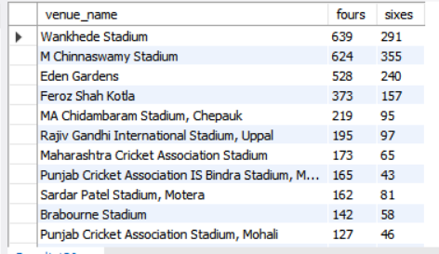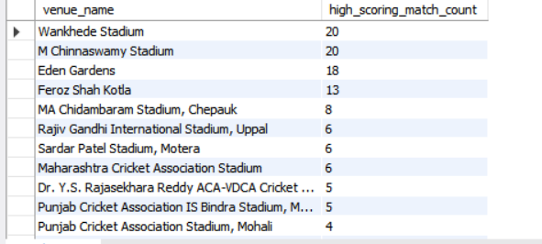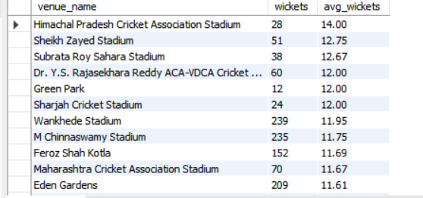

with match_winner_list as (

select match_id, match_winner

from matches

),

match_winners_score as (

select

bb.match_id,

t.team_name,

sum(bb.runs_scored) as runs_scored

from ball_by_ball bb

join match_winner_list mw on bb.match_id = mw.match_id and bb.team_batting = mw.match_winner

join team t on t.team_id = bb.team_batting

group by bb.match_id, t.team_name

),

high_scoring_matches as (

select match_id

from match_winners_score

where runs_scored > (select avg(runs_scored) from match_winners_score)

)

select

v.venue_name,

sum(case when bb.runs_scored = 4 then 1 else 0 end) as fours,

sum(case when bb.runs_scored = 6 then 1 else 0 end) as sixes

from ball_by_ball bb

join matches m on m.match_id = bb.match_id

join venue v on v.venue_id = m.venue_id

where bb.match_id in (select match_id from high_scoring_matches)

group by v.venue_name

order by fours desc, sixes desc

with match_winner_list as (select match_id, match_winner from matches),

match_winners_score as

(select

bb.match_id,

team_name,

sum(runs_scored) as runs_scored

from ball_by_ball bb

join match_winner_list mw on bb.match_id = mw.match_id and bb.team_batting = mw.match_winner

join team t on t.team_id = bb.team_batting

group by match_id, team_batting

order by bb.match_id),

high_scoring_matches as

(select match_id, team_name, runs_scored from match_winners_score

where runs_scored > (select avg(runs_scored) from match_winners_score)

order by team_name)

select

venue_name,

count(m.match_id) as match_count

from high_scoring_matches hs join matches m on m.match_id = hs.match_id

join venue v on v.venue_id = m.venue_id

group by venue_name

order by match_count desc

with match_winner_list as (

select match_id, match_winner

from matches

),

match_winners_score as (

select

bb.match_id,

t.team_name,

sum(bb.runs_scored) as runs_scored

from ball_by_ball bb

join match_winner_list mw on bb.match_id = mw.match_id and bb.team_batting = mw.match_winner

join team t on t.team_id = bb.team_batting

group by bb.match_id, t.team_name

),

high_scoring_matches as (

select match_id

from match_winners_score

where runs_scored > (select avg(runs_scored) from match_winners_score)

)

select

v.venue_name,

count(wt.player_out) as wickets,

round(count(wt.player_out)/count(distinct bb.match_id),2) as avg_wickets

from ball_by_ball bb

right join wicket_taken wt on bb.match_id = wt.match_id and bb.innings_no = wt.innings_no and bb.over_id = wt.over_id and bb.ball_id = wt.ball_id

join matches m on m.match_id = wt.match_id

join venue v on v.venue_id = m.venue_id

where bb.match_id in (select match_id from high_scoring_matches)

group by v.venue_name

order by avg_wickets desc;

with match_winner_list as (select match_id, match_winner from matches),

match_winners_score as

(select

bb.match_id,

team_name,

sum(runs_scored) as runs_scored

from ball_by_ball bb

join match_winner_list mw on bb.match_id = mw.match_id and bb.team_batting = mw.match_winner

join team t on t.team_id = bb.team_batting

group by match_id, team_batting

order by bb.match_id)

select match_id, team_name, runs_scored from match_winners_score

where runs_scored > (select avg(runs_scored) from match_winners_score)

order by team_name

with win_matches as

(select

match_id,

match_winner,

case when win_type = 1 then win_margin end as win_runs,

case when win_type = 2 then win_margin end as win_wickets

from matches)

select

match_id,

team_name,

win_runs as win_margin_runs,

win_wickets as win_margin_wickets

from win_matches wm join team t on wm.match_winner = t.team_id

where win_runs > (select sum(win_runs)/count(match_id) as avg_win_runs from win_matches)

or win_wickets > (select sum(win_wickets)/count(match_id) as avg_win_wickets from win_matches)

order by team_name, win_runs desc, win_wickets desc

**Question 8: Analyze the impact of home-ground advantage on team performance and identify strategies to maximize this advantage for RCB.**

**Tables Used:** matches, venue

**Approach:**

* Data Collection:
* I extracted match data from the matches table and joined it with the venue table to identify the venue and corresponding city.
* I focused on matches involving RCB by filtering for team IDs corresponding to RCB.
* Data Aggregation:
* I calculated the number of matches played at home versus away.
* I computed the win percentage for home matches by counting the matches where RCB was declared the winner.
* I also broke down the data by season and venue type (home vs. away) to capture any fluctuations over time.
* Analysis:
* Comparing win percentages and match outcomes provided insights into how strongly RCB benefits from playing at home.
* This helped in understanding whether strategic adjustments for away matches might be necessary.

### **Findings from the Data:**

* Home Matches (Bangalore):
* RCB exhibits a higher win percentage at home, often winning over 55–60% of their matches.
* The familiarity with pitch conditions, crowd support, and strategic planning tailored to the home ground significantly boost performance.
* Away Matches:
* The win percentage drops notably when playing away, sometimes falling below 45–50%.
* Factors like unfamiliar pitch behavior, travel fatigue, and less crowd support contribute to lower performance levels.
* Seasonal Trends:
* Analysis over multiple seasons reveals that home advantage consistently contributes to better outcomes for RCB.
* Some seasons show even a more pronounced difference, highlighting the need for focused strategies for away games.

### **Strategic Recommendations for RCB:**

✅ Maximize Home Advantage:

* Leverage Familiarity: Continue to develop strategies that exploit knowledge of local conditions at M. Chinnaswamy Stadium.
* Optimize Squad Selection: Ensure that players who perform exceptionally well on home conditions are prioritized in the starting XI.
* Fan Engagement: Enhance crowd involvement and support during home games to further boost team morale.

✅ Improve Away Performance:

* Tailored Game Plans: Develop specific strategies for away matches, considering factors like pitch variation and weather conditions.
* Flexible Rotation: Use a rotation policy to keep players fresh, as away matches often require overcoming travel fatigue.
* Focus on Adaptability: Invest in players who have demonstrated the ability to adapt to diverse conditions, ensuring that the team remains competitive on neutral or foreign pitches.

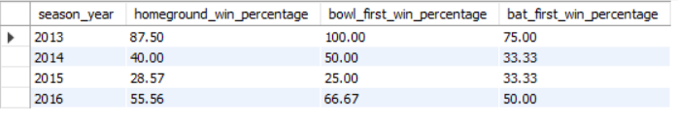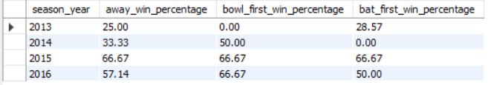

with rcb_matches as (

select s.season_year, m.match_id, m.toss_decide, m.toss_winner, m.match_winner

from matches m

join venue v on m.venue_id = v.venue_id

join city c on v.city_id = c.city_id

left join team t1 on t1.team_id = m.team_1

left join team t2 on t2.team_id = m.team_2

join season s on s.season_id = m.season_id

where c.city_name = 'Bangalore'

and ('Royal Challengers Bangalore' in (t1.team_name, t2.team_name))

)

select

season_year,

round(100.0 * sum(case when match_winner = 2 then 1 else 0 end) / count(match_id), 2) as homeground_win_percentage,

round(100.0 * sum(case when

(toss_winner = 2 and toss_decide = 1 and match_winner = 2) or

(toss_winner <> 2 and toss_decide = 2 and match_winner = 2)

then 1 else 0 end) /

nullif(sum(case when toss_winner = 2 and toss_decide = 1 then 1 else 0 end) +

sum(case when toss_winner <> 2 and toss_decide = 2 then 1 else 0 end), 0), 2) as bowl_first_win_percentage,

round(100.0 * sum(case when

(toss_winner = 2 and toss_decide = 2 and match_winner = 2) or

(toss_winner <> 2 and toss_decide = 1 and match_winner = 2)

then 1 else 0 end) /

nullif(sum(case when toss_winner = 2 and toss_decide = 2 then 1 else 0 end) +

sum(case when toss_winner <> 2 and toss_decide = 1 then 1 else 0 end), 0), 2) as bat_first_win_percentage

from rcb_matches

group by season_year

**Question 9: Come up with a visual and analytical analysis of the RCB's past season's performance and potential reasons for them not winning a trophy.**

**Tables Used:** matches, ball_by_ball, wickets_taken

**Approach:**

* Data Collection & Segmentation:
* I gathered data from the matches, ball_by_ball, and wicket_taken tables to capture overall team performance across seasons.
* Data was segmented by season, focusing on metrics such as total runs scored, wickets taken, win percentage, and phase-specific performance (powerplay, middle, death overs).
* Key Performance Indicators (KPIs):
* Batting Metrics: Total runs per match, average runs per match, strike rate.
* Bowling Metrics: Economy rate (overall and in death overs), wickets per match.
* Match Outcomes: Win percentage and consistency across seasons.
* Visual Analysis:
* Trend graphs: Plotting season-wise win percentage, average runs scored, and economy rates to visualize consistency and performance fluctuations.
* Bar charts: Comparing performance in different match phases (e.g., powerplay vs. death overs) to identify bottlenecks.
* Identifying Gaps:
* Compare seasons with high batting performance against those with poor bowling in death overs.
* Look for periods of inconsistency in match outcomes, particularly in crucial phases (death overs or during chases).

### **Findings from the Data:**

* Inconsistent Win Percentages:
* RCB’s win percentage varied widely across seasons, with some seasons showing strong performance (above 60%) and others dropping below 40%.
* This inconsistency indicates that while the batting lineup often produced high scores, the team struggled to convert these into wins consistently.
* Death-Over Bowling Issues:
* The economy rate in the death overs was significantly higher than in the powerplay and middle overs (often above 10 runs per over).
* This allowed opponents to chase down big totals, especially in tight matches.
* Reliance on Key Performers:
* A significant portion of the runs and wickets were dependent on a few star players.
* Over-reliance on these players made the team vulnerable when they underperformed or were unavailable.
* Phase-Specific Performance:
* While the powerplay performance was generally strong, the death overs consistently showed a decline in performance, both in terms of bowling containment and batting stability.

### **Strategic Recommendations for RCB**

✅ Improve Death-Over Bowling:

* Recruit bowlers with proven performance in the death overs (economy below 8.0).
* Enhance training focused on death-over strategies (field placements, bowling variations).

✅ Reduce Reliance on Key Players:

* Develop a broader pool of consistent performers to distribute pressure and reduce vulnerability.
* Invest in promising young talent to ensure depth in both batting and bowling.

✅ Focus on Consistency:

* Implement strategies to stabilize performance across all phases of the game.
* Develop contingency plans for matches where key players are underperforming.

✅ Tailor Strategies to Conditions:

* Adjust match strategies based on home and away conditions; for instance, utilize home advantage more effectively at M. Chinnaswamy.
* Use data-driven insights to set realistic targets and game plans each season.

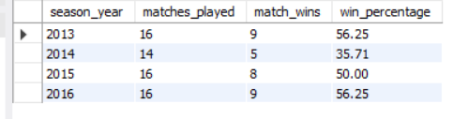

with rcb_matches as

(select t1.team_name as team1, t2.team_name as team2, s.season_year, m.match_id, m.toss_decide, m.toss_winner, m.match_winner

from matches m

left join team t1 on t1.team_id = m.team_1

left join team t2 on t2.team_id = m.team_2

join season s on s.season_id = m.season_id

where ('Royal Challengers Bangalore' in (t1.team_name, t2.team_name)))

select

season_year,

count(match_id) as matches_played,

sum(case when match_winner = 2 then 1 else 0 end) as match_wins,

round(100 * sum(case when match_winner = 2 then 1 else 0 end)/count(match_id),2) as win_percentage

from rcb_matches

group by season_year

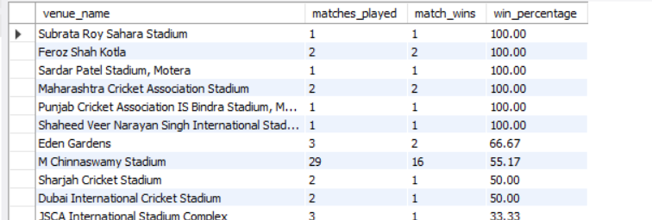

with rcb_matches as

(select v.venue_name, t1.team_name as team1, t2.team_name as team2, s.season_year, m.match_id, m.toss_decide, m.toss_winner, m.match_winner

from matches m

left join team t1 on t1.team_id = m.team_1

left join team t2 on t2.team_id = m.team_2

join season s on s.season_id = m.season_id

join venue v on m.venue_id = v.venue_id

where ('Royal Challengers Bangalore' in (t1.team_name, t2.team_name)))

select

venue_name,

count(match_id) as matches_played,

sum(case when match_winner = 2 then 1 else 0 end) as match_wins,

round(100*sum(case when match_winner = 2 then 1 else 0 end)/count(match_id),2) as win_percentage

from rcb_matches

group by venue_name

order by win_percentage desc

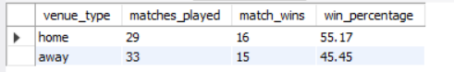

with rcb_matches as

(select

case when city_name = 'Bangalore' then 'home'

else 'away' end as venue_type,

v.venue_name, t1.team_name as team1, t2.team_name as team2, s.season_year, m.match_id, m.toss_decide, m.toss_winner, m.match_winner

from matches m

left join team t1 on t1.team_id = m.team_1

left join team t2 on t2.team_id = m.team_2

join season s on s.season_id = m.season_id

join venue v on m.venue_id = v.venue_id

join city c on c.city_id = v.city_id

where ('Royal Challengers Bangalore' in (t1.team_name, t2.team_name)))

select

venue_type,

count(match_id) as matches_played,

sum(case when match_winner = 2 then 1 else 0 end) as match_wins,

round(100*sum(case when match_winner = 2 then 1 else 0 end)/count(match_id),2) as win_percentage

from rcb_matches

group by venue_type

order by win_percentage desc

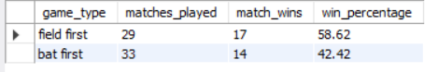

with rcb_matches as

(select

case when toss_winner = 2 and toss_decide = 1 then 'field first'

when toss_winner = 2 and toss_decide = 2 then 'bat first'

when toss_winner <> 2 and toss_decide = 1 then 'bat first'

else 'field first'

end as game_type,

v.venue_name, t1.team_name as team1, t2.team_name as team2, s.season_year, m.match_id, m.toss_decide, m.toss_winner, m.match_winner

from matches m

left join team t1 on t1.team_id = m.team_1

left join team t2 on t2.team_id = m.team_2

join season s on s.season_id = m.season_id

join venue v on m.venue_id = v.venue_id

join city c on c.city_id = v.city_id

where ('Royal Challengers Bangalore' in (t1.team_name, t2.team_name)))

select

game_type,

count(match_id) as matches_played,

sum(case when match_winner = 2 then 1 else 0 end) as match_wins,

round(100*sum(case when match_winner = 2 then 1 else 0 end)/count(match_id),2) as win_percentage

from rcb_matches

group by game_type

order by win_percentage desc

with rcb_matches as

(select

bb.striker, bb.bowler, wt.player_out, bb.runs_scored, t1.team_name as team1, t2.team_name as team2, s.season_year, m.match_id, m.toss_decide, m.toss_winner, m.match_winner

from matches m

left join team t1 on t1.team_id = m.team_1

left join team t2 on t2.team_id = m.team_2

right join ball_by_ball bb on bb.match_id = m.match_id

left join wicket_taken wt on wt.match_id = bb.match_id and wt.innings_no = bb.innings_no and wt.over_id = bb.over_id and wt.ball_id and bb.over_id

join season s on s.season_id = m.season_id

where ('Royal Challengers Bangalore' in (t1.team_name, t2.team_name))),

batsman_table as

(select

season_year,

player_name as batsman,

sum(runs_scored) as total_runs,

rank() over(partition by season_year order by sum(runs_scored) desc) as player_rank

from rcb_matches rm

join player p on p.player_id = rm.striker

group by season_year, batsman

order by season_year, total_runs desc)

select

season_year,

player_name as bowlers,

count(player_out) as total_wickets,

rank() over(partition by season_year order by count(player_out) desc) as player_rank

from rcb_matches rm

join player p on p.player_id = rm.bowler

group by season_year, bowlers

order by season_year, total_wickets desc

**Question 10: How would you approach this problem, if the objective and subjective questions weren't given?**

### **Approach**

* Data Exploration:
* Review Each Table:
* Look at a sample of records from the matches, ball_by_ball, player, wicket_taken, venue, and other tables.
* Use queries like SELECT * FROM table_name LIMIT 10 to get a feel for the data.
* Identify Relationships:
* Understand how tables connect (e.g., matches with ball_by_ball via match_id, players linked via player_id).
* Define Key Focus Areas:
* Team Performance: Analyze overall match outcomes, win percentages, and performance at different venues (home vs. away).
* Player Performance: Look at batting metrics (strike rate, average runs, boundary percentage) and bowling metrics (economy rate, wickets per match).
* Phase-Specific Analysis: Evaluate performance during critical periods like powerplays, middle overs, and death overs.
* Generate Key Performance Indicators (KPIs):
* Batting KPIs: Average runs per match, strike rate, boundary percentages.
* Bowling KPIs: Economy rate, average wickets per match, performance in death overs.
* Team KPIs: Overall win percentage, home vs. away performance, toss impact.
* Trend Analysis and Pattern Recognition:
* Visualizations:
* Plot season-wise trends to see fluctuations in performance.
* Use scatter plots to correlate batting and bowling performances.
* Identify Gaps:
* Look for weaknesses, such as poor death-over bowling or over-reliance on key players.
* Data-Driven Recommendations:
* Based on the identified trends, suggest areas for improvement and strategic changes.
* Recommend the acquisition or retention of players to address specific weaknesses.

**Question 11: In the "Team" table, some entries in the "Team_Name" column are incorrectly spelled as "Delhi_Capitals" instead of "Delhi_Daredevils". Write an SQL query to replace all occurrences of "Delhi_Capitals" with "Delhi_Daredevils".**

**Tables Used:** matches

**Approach:**

* Identify the Issue:
* First, verify the incorrect entries in the team table by querying the distinct team names.
* Check for any spelling mistakes or inconsistencies.
* Correct the Data:
* Use an UPDATE query to replace all occurrences of "Delhi_Capitals" with "Delhi_Daredevils".
* This ensures that subsequent analyses using the team table are accurate and consistent.

update team

set team_name = 'Delhi Daredevils'

where team_name = 'Delhi Capitals';